**AWS**

Custom policy

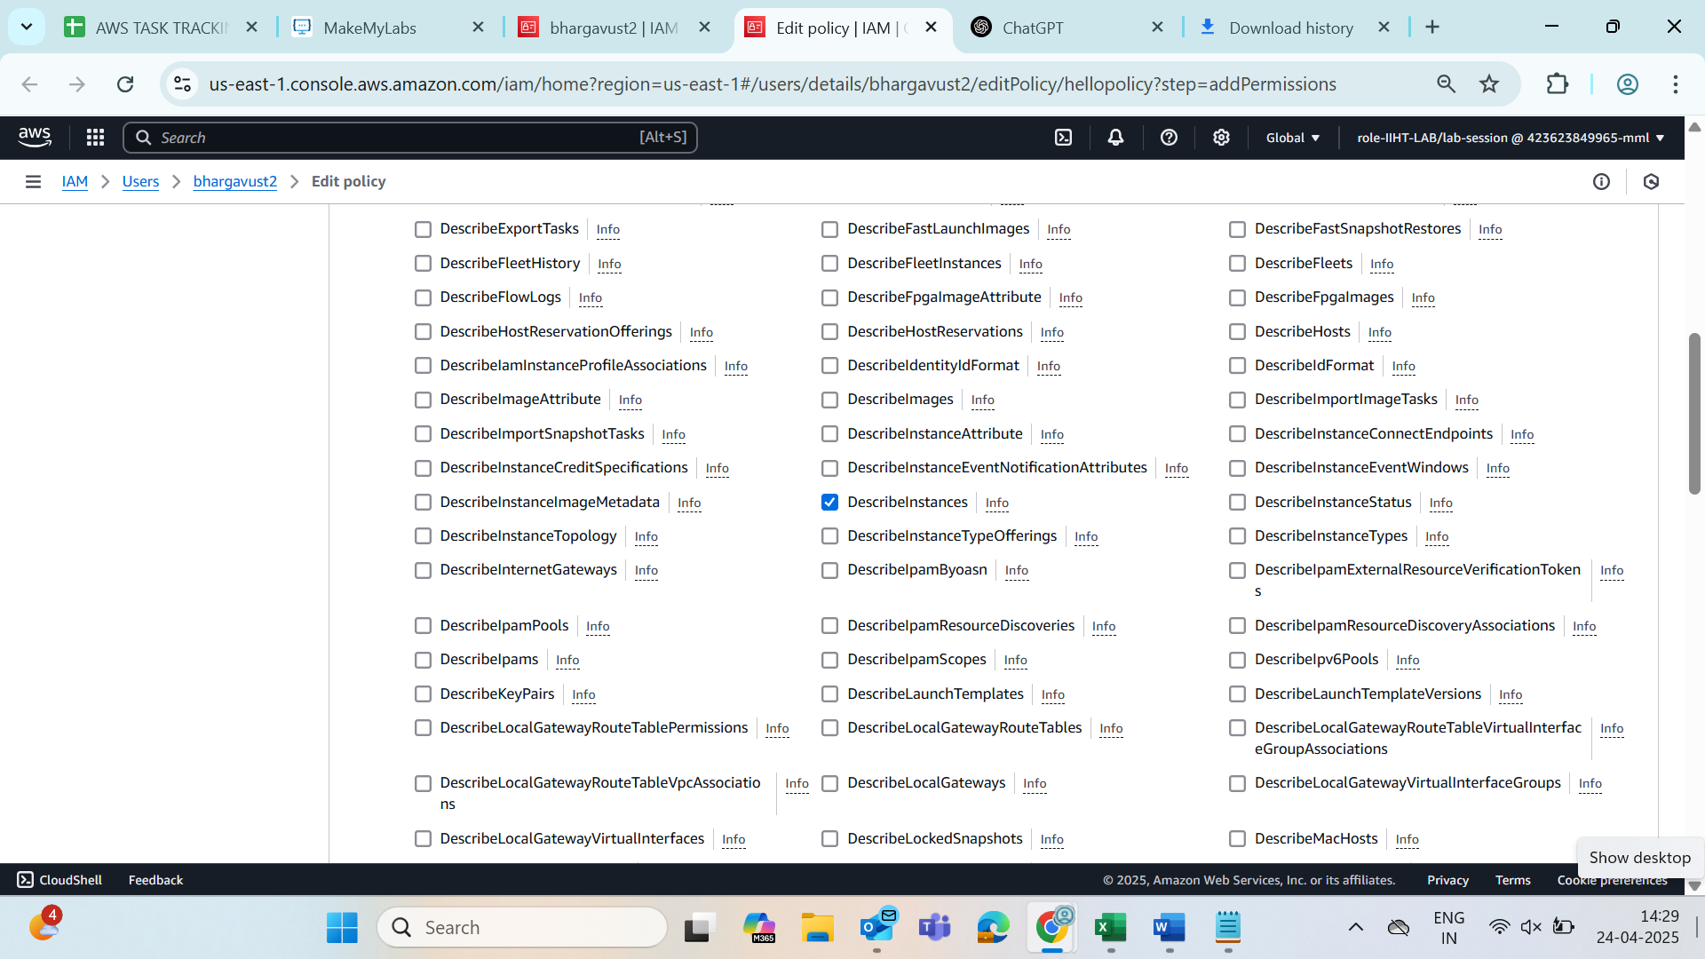

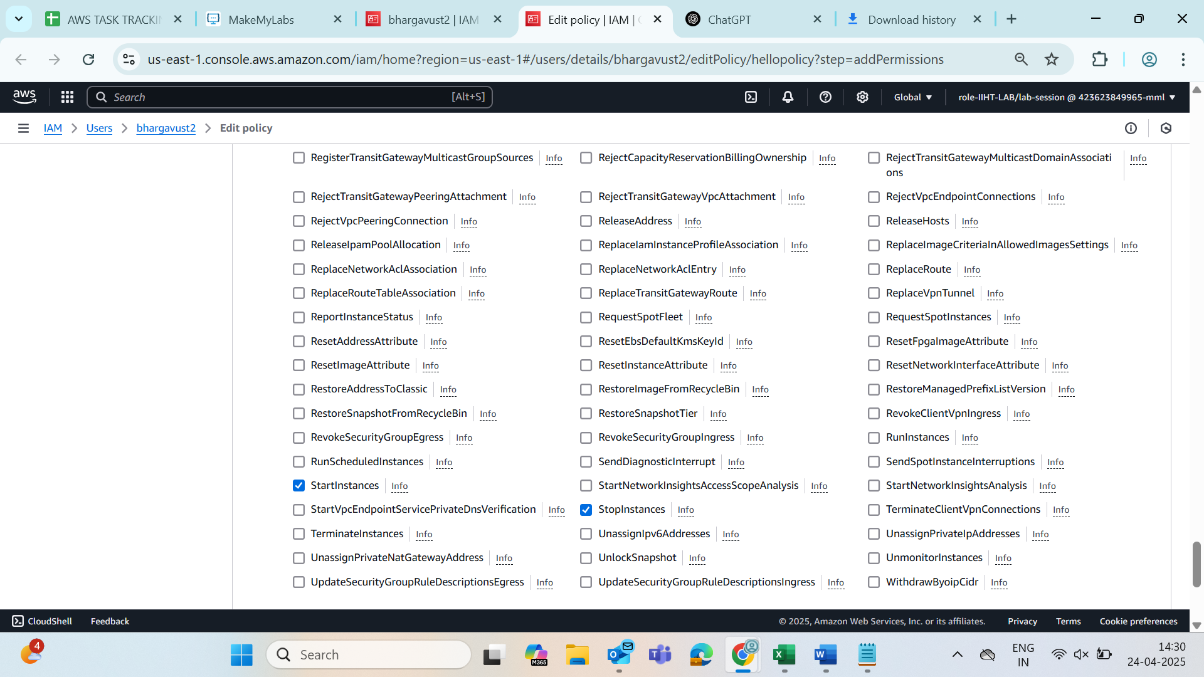

->RunInstances in write

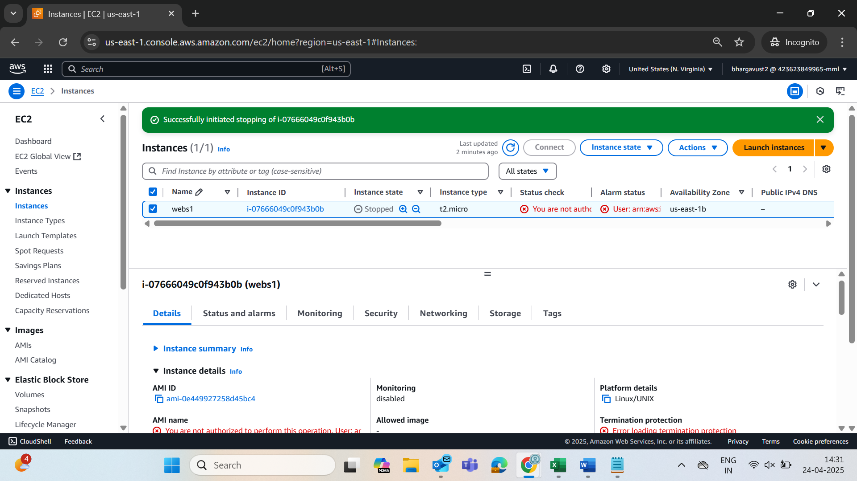

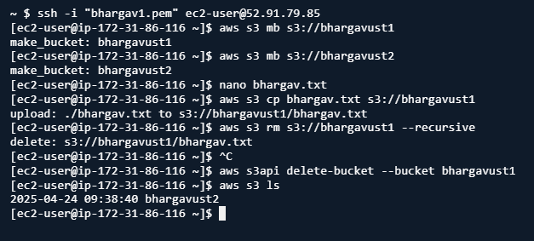

Created new key pair

aws ec2 create-key-pair --key-name MyNewKeyPair --query 'KeyMaterial' -- output text > MyNewKeyPair.pem





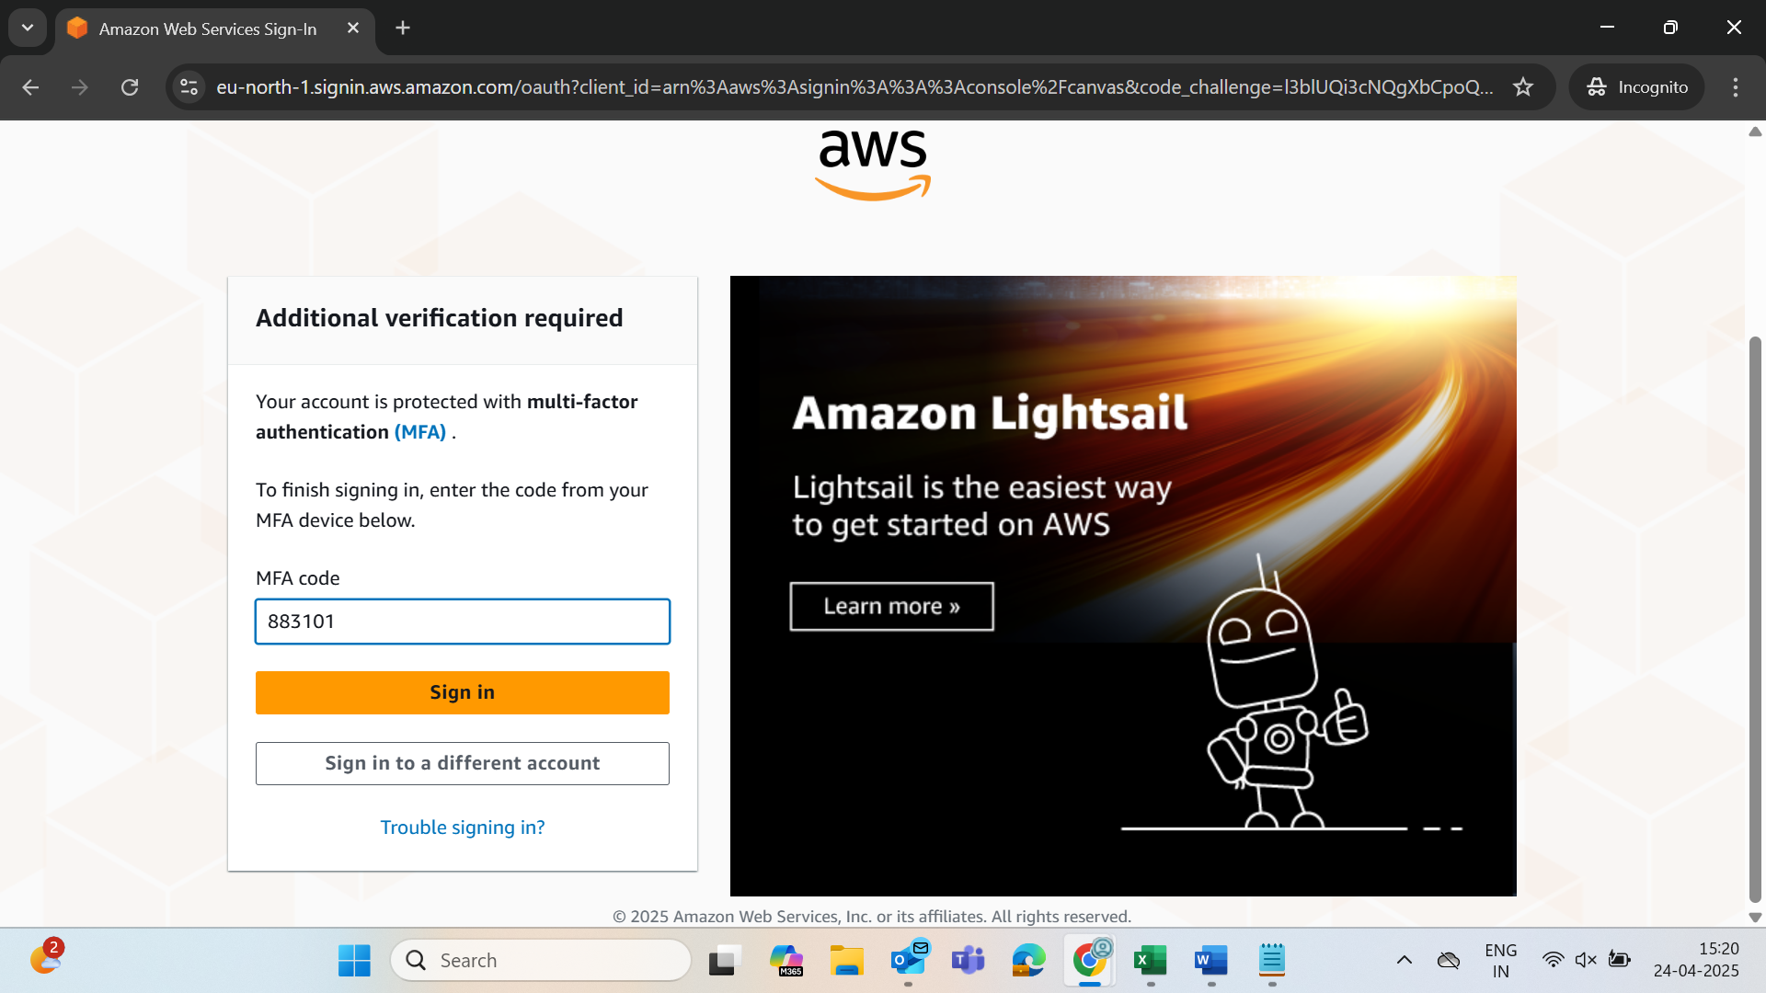

Created instance

aws ec2 run-instances --image-id ami-06616d5385afedaa5 --count 1 --instance-type t2.micro --key-name bhargav1

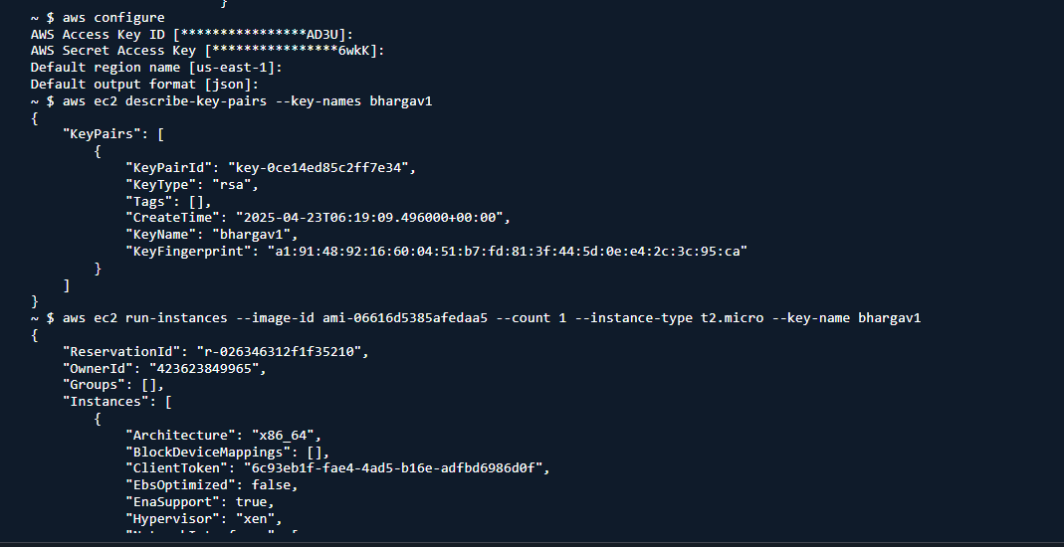

Stopped instance

aws ec2 stop-instances --instance-ids i-036c29a38a8ec891f

for again to start

aws ec2 start-instances --instance-ids i-036c29a38a8ec891f

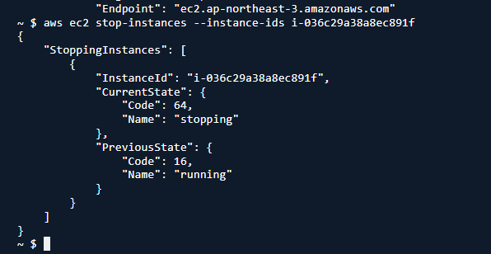

**Launch EC2 with Apache Install via User Data**

aws ec2 run-instances \

--image-id ami-06616d5385afedaa5 \

--count 1 \

--instance-type t2.micro \

--key-name bhargav1 \

--security-group-ids sg-0a7ae1b725b7b8291 \

--tag-specifications 'ResourceType=instance,Tags=[{Key=Name,Value=apache-web-server}]' \

--user-data '#!/bin/bash

yum update -y

yum install -y httpd

systemctl start httpd

systemctl enable httpd

echo "<h1>Hello from Apache Web Server on EC2</h1>" > /var/www/html/index.html'

**Ensure Port 80 (HTTP) is Allowed**

aws ec2 authorize-security-group-ingress \

--group-id sg-0a7ae1b725b7b8291 \

--protocol tcp \

--port 80 \

--cidr 0.0.0.0/0

**Get the Public IP**

aws ec2 describe-instances \

--filters "Name=tag:Name,Values=apache-web-server" \

--query "Reservations[*].Instances[*].[InstanceId,State.Name,PublicIpAddress]" \

--output table

